**USE OF INBUILT SENSORS IN SMART PHONE TO DEVELOP FETAL DOPTONE**

**UML DIAGRAMS PORTRAYING FUNCTIONALITY**

**TEAM:**

* **Project Directors :**

Prof. Abhishek Srivastava

Dr. Sachin Gothi

* **Team of Students :**

Srikrishna Mamillapalli | 180001029

Kandula Chandra Kanth | 180001024

Pulivarthi Karthik Chakravarthi | 180001040

Kumpatla Vijay Babu | 180001027

* **Course Instructor :**

Dr. Puneet Gupta

CSE 258 SOFTWARE ENGINEERING LAB

Spring 2020

**USE CASE DIAGRAM SHOWING INTERACTIONS**

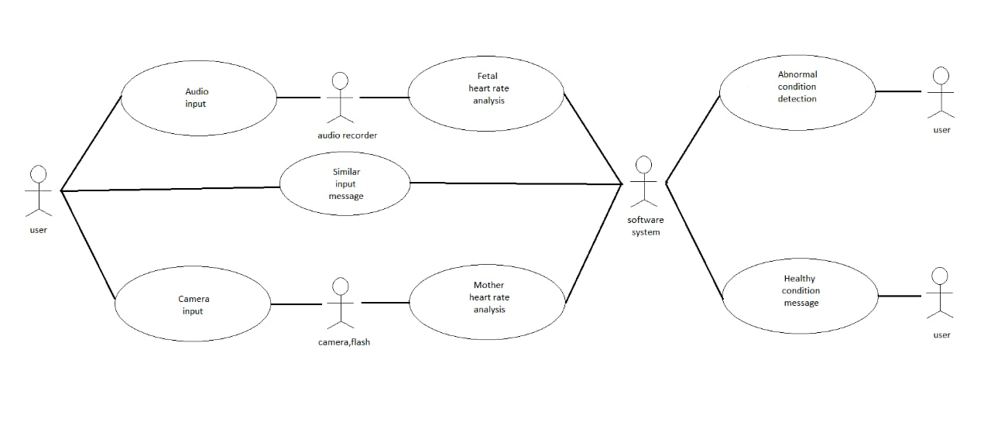

1. Tabular description of the ‘Audio Input’ use case:

|  |  |
| --- | --- |
| Actors | User, Audio Recorder |
| Description | User places her mobile on her stomach so that the voice recorder is able to record the fetal heart beat |

2. Tabular description of the ‘Camera Input’ use case:

|  |  |
| --- | --- |
| Actors | User, Camera, Flash |
| Description | User places her finger on the camera and turns on the flash |

3. Tabular description of the ‘Fetal heart rate analysis’ use case:

|  |  |
| --- | --- |
| Actors | Audio Recorder, Software System |
| Description | The recorded audio from the audio recorder is processed by the software system to produce Fetal heart rate graph by calculating the BPM |

4. Tabular description of the ‘Mother heart rate analysis’ use case:

|  |  |
| --- | --- |
| Actors | Camera, Flash, Software System |
| Description | When the user puts her finger on the camera with flash on, the software system calculates the user’s heart beat |

5. Tabular description of the ‘Similar input message’ use case:

|  |  |
| --- | --- |
| Actors | Software System, User |
| Description | If the same data is processed by both the Audio Recorder and Camera, Flash (both record mother’s heart rate), then the software system displays a message for the user to again repeat the process again till both the heart rates differ significantly |

6. Tabular description of the ‘Abnormal Condition Detection’ use case:

|  |  |
| --- | --- |
| Actors | Software System, User |
| Description | If any abnormality is detected, then the software system displays an alert message stating abnormal condition, the collected data is documented and accordingly a message is displayed |

7. Tabular description of the ‘Healthy condition message’ use case:

|  |  |
| --- | --- |
| Actors | Software System, User |
| Description | If every condition is satisfied perfectly, then the software system displays a message that tells the baby is in a healthy condition |

**STATE DIAGRAM SHOWING FUNCTIONALITY**

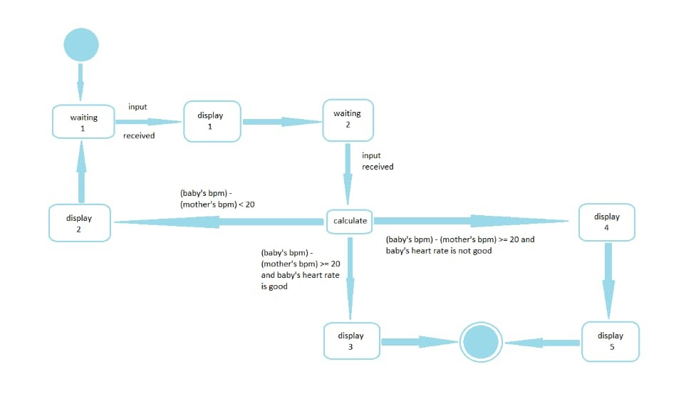

|  |  |
| --- | --- |
| State | Description |
| Waiting 1 | The software system is waiting for the input from the audio recorder |
| Display 1 | Once the input is received the bpm of the baby is calculated and “Place the tip of your index finger covering the camera hole completely” message is displayed |
| Waiting 2 | The software system is waiting for the input from the camera and flash |
| Calculate | Once the input is received from camera and flash the bpm of the mother is calculated and the proper conditions are checked |
| Display 2 | If |(baby’s bpm) – (mother’s bpm)| < 20, then a message saying that “The initially calculated bpm is the mother’s heart rate and not the fetal heart rate” is displayed along with asking user(mother) to repeat the same process again |
| Display 3 | If |(baby’s bpm) – (mother’s bpm)| >= 20 and the baby’s heart rate is healthy, the message “The baby is in healthy condition” is displayed |
| Display 4 | If |(baby’s bpm) – (mother’s bpm)| >= 20 and the baby’s heart rate is abnormal, then the message “Abnormal condition” is displayed and the recorded graph and data is documented |
| Display 5 | After documenting data , “Data is documented and is available for sharing” message is displayed |